Discovering My Spiritual Gifts Series June 19, 2022
Romans 12:3—8, Ephesians 4:11-13, Psalm 150:3-5, Exodus 31:1-11
Spiritual Gift List & Definitions
- Prophecy: the distinctive ability to boldly declare the truth of God, regardless of the consequences, calling people to righteous living
- Serving: the distinctive ability to identify and meet the practical needs of others
- Teaching: the distinctive ability to employ a logical, systematic approach to Biblical study in preparation for clearly communicating practical truth to the body of Christ
  - Illustration: Matthew 5:3-12
- Exhortation: the distinctive ability to appropriately communicate words of encouragement, challenge, or rebuke in the body of Christ
- Illustration: Acts 17:22-39
- Giving: the distinctive ability to cheerfully and generously contribute personal resources to God's work
  - Illustration: Luke 21:1-4
- Leading: the distinctive ability to influence others according to a the Biblical purposes of the church
  - Illustration: Acts 6:1-6
- Mercy: the distinctive ability to feel sincere empathy and compassion in a way that results in practical relief for people's hurts, pain and suffering
  - Illustration: Christian doctors, nurses, physical therapists, counselors, provide physical and emotional relief to life’s problems
- Evangelists: the distinctive ability to boldly declare the truth of God, regardless of the consequences, calling people to righteous living
  - Illustration: Acts 21:8, 2 Timothy 4:5
- Pastors-teachers (shepherd): the distinctive ability to assume responsibility for the spiritual growth and Christian community of a group of believers
  - Illustration: 1 Peter 5:1-3
- Music: the distinctive ability to play a musical instrument or sing in such as way that leads the people of God in worship of Him
  - Illustration: Psalm 33:3, 150:3-5
  - See also 1 Samuel 16:12-23
- Craftsmanship: the distinctive ability to use your hands and mind to benefit other believers through artistic, creative or a wide variety of construction arenas
  - Illustration: Exodus 31:1-11
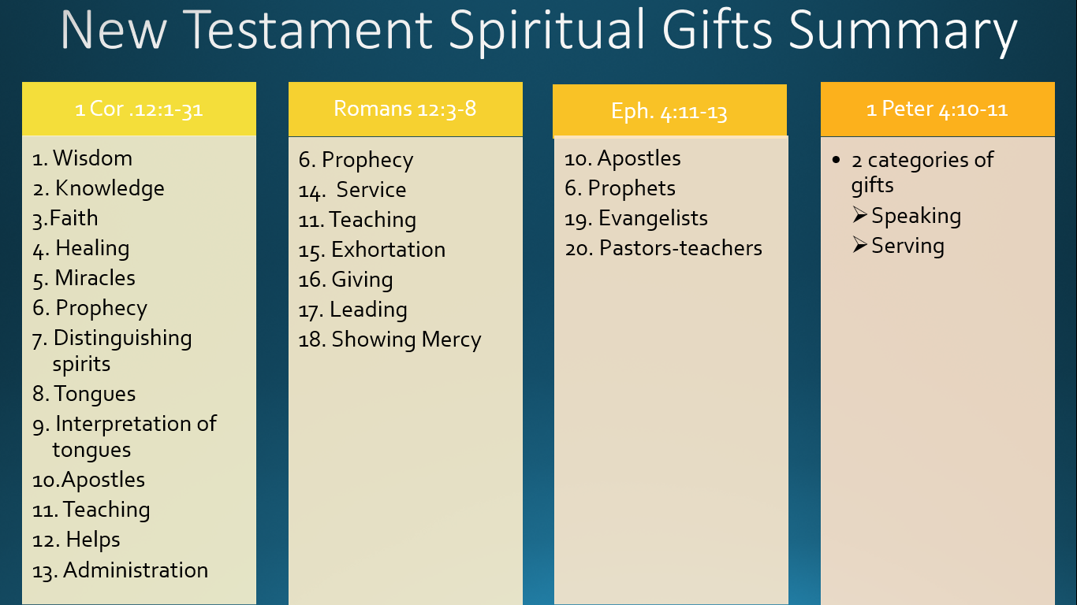

All Christians Must Use Their Spiritual Gifts
- Serving the Lord and the church is not optional if you are a born-again follower of Jesus Christ
  - Every time you use your gift, God is glorified
  - Every time you use your gift, the church grows
  - Every time you use your gift, the Holy Spirit works in you
Discovering My Spiritual Gifts Series June 19, 2022
Romans 12:3—8, Ephesians 4:11-13, Psalm 150:3-5, Exodus 31:1-11
Spiritual Gift List & Definitions
- Prophecy: the distinctive ability to boldly declare the truth of God, regardless of the consequences, calling people _________________
- Serving: the distinctive ability to identify and meet the __________________________________ of others
- Teaching: the distinctive ability to employ a logical, systematic approach to _________________ in preparation for clearly communicating practical truth to the body of Christ
  - Illustration: Matthew 5:3-12
- Exhortation: the distinctive ability to ____________________ words of encouragement, challenge, or rebuke in the body of Christ
- Illustration: Acts 17:22-39
- Giving: the distinctive ability to cheerfully and _________________ personal resources to God's work
  - Illustration: Luke 21:1-4
- Leading: the distinctive ability to _________________ according to a the Biblical purposes of the church
  - Illustration: Acts 6:1-6
- Mercy: the distinctive ability to feel _________________ and compassion in a way that results in practical relief for people's hurts, pain and suffering
  - Illustration: Christian doctors, nurses, physical therapists, counselors, provide physical and emotional relief to life’s problems
- Evangelists: the distinctive ability to boldly ____________________, regardless of the consequences, calling people to righteous living
  - Illustration: Acts 21:8, 2 Timothy 4:5
Discovering My Spiritual Gifts Series June 19, 2022
Romans 12:3—8, Ephesians 4:11-13, Psalm 150:3-5, Exodus 31:1-11
Spiritual Gift List & Definitions
- Prophecy: the distinctive ability to boldly declare the truth of God, regardless of the consequences, calling people _________________
- Serving: the distinctive ability to identify and meet the __________________________________ of others
- Teaching: the distinctive ability to employ a logical, systematic approach to _________________ in preparation for clearly communicating practical truth to the body of Christ
  - Illustration: Matthew 5:3-12
- Exhortation: the distinctive ability to ____________________ words of encouragement, challenge, or rebuke in the body of Christ
- Illustration: Acts 17:22-39
- Giving: the distinctive ability to cheerfully and _________________ personal resources to God's work
  - Illustration: Luke 21:1-4
- Leading: the distinctive ability to _________________ according to a the Biblical purposes of the church
  - Illustration: Acts 6:1-6
- Mercy: the distinctive ability to feel _________________ and compassion in a way that results in practical relief for people's hurts, pain and suffering
  - Illustration: Christian doctors, nurses, physical therapists, counselors, provide physical and emotional relief to life’s problems
- Evangelists: the distinctive ability to boldly ____________________, regardless of the consequences, calling people to righteous living
  - Illustration: Acts 21:8, 2 Timothy 4:5
- Pastors-teachers (shepherd): the distinctive ability to assume responsibility for the _________________ and Christian community of a group of believers
  - Illustration: 1 Peter 5:1-3
- Music: the distinctive ability to ______________________________ in such as way that leads the people of God in worship of Him
  - Illustration: Psalm 33:3, 150:3-5
  - See also 1 Samuel 16:12-23
- Craftsmanship: the distinctive ability to ______________________ and mind to benefit other believers through artistic, creative or a wide variety of construction arenas
  - Illustration: Exodus 31:1-11

All Christians Must Use Their Spiritual Gifts
- Serving the Lord and the church is not optional if you are a born-again follower of Jesus Christ
  - Every time you use your gift, God is glorified
  - Every time you use your gift, the church grows
  - Every time you use your gift, the Holy Spirit works in you
- Pastors-teachers (shepherd): the distinctive ability to assume responsibility for the _________________ and Christian community of a group of believers
  - Illustration: 1 Peter 5:1-3
- Music: the distinctive ability to ______________________________ in such as way that leads the people of God in worship of Him
  - Illustration: Psalm 33:3, 150:3-5
  - See also 1 Samuel 16:12-23
- Craftsmanship: the distinctive ability to ______________________ and mind to benefit other believers through artistic, creative or a wide variety of construction arenas
  - Illustration: Exodus 31:1-11

All Christians Must Use Their Spiritual Gifts
- Serving the Lord and the church is not optional if you are a born-again follower of Jesus Christ
  - Every time you use your gift, God is glorified
  - Every time you use your gift, the church grows
  - Every time you use your gift, the Holy Spirit works in you

