Romans Series July 2, 2023
The Sovereignty of God – Romans 9:14-33
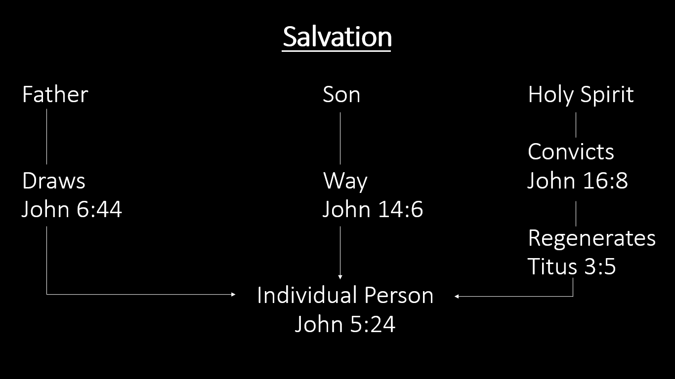
1. God’s Mercy and Justice Romans 9:14-18
- Romans 9:15 is a direct quote of Exodus 33:19
  - In context, Moses is meeting with God and acting as the intermediary with Israel
- This demonstrates the nature of God
  - Exodus 34:6b–7a
⁶ “The Lord, the Lord God, compassionate and gracious, slow to anger, and abounding in lovingkindness and truth; ⁷ who keeps lovingkindness for thousands, who forgives iniquity, transgression and sin.”
- No one can earn God’s favor
  - You cannot do enough service work, give enough financially, or go on enough missions trips to ingratiate yourself with God
- Pharaoh illustrates the mercy and justice of God
  - Moses came to Pharaoh over 10 different times
  - Pharaoh had the option to release the Israelites from captivity
  - God hardened Pharaoh’s heart (Exodus 4:21)
  - Pharaoh hardened his own heart (Exodus 8:15)
2. God’s Wrath and Patience Romans 9:19-24
- Since God is all powerful (omnipotent), He exercises that power according to His perfect will
  - God is merciful toward upon some people, both Jews and Gentiles (salvation is not based on birth)
  - God is patient to allow time for those headed for wrath and destruction so that they are without excuse before Him (human responsibility)
- Illustration: the potter and the clay
  - Potter determines what will be made
  - The clay is the object the potter uses in making molds
- God’s patience toward all mankind enables people to see the vast riches of God and give Him glory
  - To both Jews and Gentiles alike
- Those who reject Him ultimately receive His wrath in eternal destruction
3. God Calls Both Jews and Gentiles Romans 9:25-29
- Drawing from prophecies in Hosea 1:10 and 2:23, God shows that He calls people to Himself regardless of their ethnic origin
  - The Jews thought they were the only people of God
- Drawing from prophecies in Isaiah 10:22-23, God shows that He calls people to Himself who are the descendants of Abraham (from the nation of Israel)
  - Some, but not all, Israelites will ultimately be saved
4. The Response of God’s Choice Must Ultimately Be Faith and Belief Romans 9:30-33
- Many Jews wrongly think that they will be saved because of their lineage and because they follow the Law
  - They “stumbled” over God’s provision of salvation through Jesus Christ
  - “He who believes in Him will not be disappointed” (v. 33b)!
Romans Series July 2, 2023
The Sovereignty of God – Romans 9:14-33
1. God’s ____________________________________ Romans 9:14-18
- Romans 9:15 is a direct quote of Exodus 33:19
  - In context, Moses is meeting with God and acting as the intermediary with Israel
- This demonstrates the nature of God
  - Exodus 34:6b–7a
⁶ “The Lord, the Lord God, compassionate and gracious, slow to anger, and abounding in lovingkindness and truth; ⁷ who keeps lovingkindness for thousands, who forgives iniquity, transgression and sin.”
- No one can earn God’s favor
  - You cannot do enough service work, give enough financially, or go on enough missions trips to ingratiate yourself with God
- Pharaoh illustrates the mercy and justice of God
  - Moses came to Pharaoh over 10 different times
  - Pharaoh had the option to release the Israelites from captivity
  - God hardened Pharaoh’s heart (Exodus 4:21)
  - Pharaoh hardened his own heart (Exodus 8:15)
Romans Series July 2, 2023
The Sovereignty of God – Romans 9:14-33
1. God’s ____________________________________ Romans 9:14-18
- Romans 9:15 is a direct quote of Exodus 33:19
  - In context, Moses is meeting with God and acting as the intermediary with Israel
- This demonstrates the nature of God
  - Exodus 34:6b–7a
⁶ “The Lord, the Lord God, compassionate and gracious, slow to anger, and abounding in lovingkindness and truth; ⁷ who keeps lovingkindness for thousands, who forgives iniquity, transgression and sin.”
- No one can earn God’s favor
  - You cannot do enough service work, give enough financially, or go on enough missions trips to ingratiate yourself with God
- Pharaoh illustrates the mercy and justice of God
  - Moses came to Pharaoh over 10 different times
  - Pharaoh had the option to release the Israelites from captivity
  - God hardened Pharaoh’s heart (Exodus 4:21)
  - Pharaoh hardened his own heart (Exodus 8:15)
2. God’s ____________________________________ Romans 9:19-24
- Since God is all powerful (omnipotent), He exercises that power according to His perfect will
  - God is merciful toward upon some people, both Jews and Gentiles (salvation is not based on birth)
  - God is patient to allow time for those headed for wrath and destruction so that they are without excuse before Him (human responsibility)
- Illustration: the potter and the clay
  - Potter determines what will be made
  - The clay is the object the potter uses in making molds
- God’s patience toward all mankind enables people to see the vast riches of God and give Him glory
  - To both Jews and Gentiles alike
- Those who reject Him ultimately receive His wrath in eternal destruction
3. God Calls Both ______________________________ Romans 9:25-29
- Drawing from prophecies in Hosea 1:10 and 2:23, God shows that He calls people to Himself regardless of their ethnic origin
  - The Jews thought they were the only people of God
- Drawing from prophecies in Isaiah 10:22-23, God shows that He calls people to Himself who are the descendants of Abraham (from the nation of Israel)
  - Some, but not all, Israelites will ultimately be saved
4. The Response of God’s Choice Must Ultimately Be _______________ Romans 9:30-33
- Many Jews wrongly think that they will be saved because of their lineage and because they follow the Law
  - They “stumbled” over God’s provision of salvation through Jesus Christ
  - “He who believes in Him will not be disappointed” (v. 33b)!
2. God’s ____________________________________ Romans 9:19-24
- Since God is all powerful (omnipotent), He exercises that power according to His perfect will
  - God is merciful toward upon some people, both Jews and Gentiles (salvation is not based on birth)
  - God is patient to allow time for those headed for wrath and destruction so that they are without excuse before Him (human responsibility)
- Illustration: the potter and the clay
  - Potter determines what will be made
  - The clay is the object the potter uses in making molds
- God’s patience toward all mankind enables people to see the vast riches of God and give Him glory
  - To both Jews and Gentiles alike
- Those who reject Him ultimately receive His wrath in eternal destruction
3. God Calls Both ______________________________ Romans 9:25-29
- Drawing from prophecies in Hosea 1:10 and 2:23, God shows that He calls people to Himself regardless of their ethnic origin
  - The Jews thought they were the only people of God
- Drawing from prophecies in Isaiah 10:22-23, God shows that He calls people to Himself who are the descendants of Abraham (from the nation of Israel)
  - Some, but not all, Israelites will ultimately be saved
4. The Response of God’s Choice Must Ultimately Be _______________ Romans 9:30-33
- Many Jews wrongly think that they will be saved because of their lineage and because they follow the Law
  - They “stumbled” over God’s provision of salvation through Jesus Christ
  - “He who believes in Him will not be disappointed” (v. 33b)!

