End Time Events October 29, 2023
Are We Living in the End Time? – Matthew 24:1-14
End time prophecy Matthew 24:1-3
1. When will these things happen?
2. What will be the sign of Your coming and
of the end of the age?
Signs of the End of Times Matthew 24:4-14
1. False prophets and false Christs will deceive the world
  - Deception has been a key tactic of Satan since Genesis 3
2. World-wide war
- The war(s) will be accompanied by natural disasters such as earthquakes and famines (starvation)
  - This does not mean the end of time is at hand, but rather just beginning: “the beginning of birth pangs”
3. Persecution of Israel
- There will be death of many of God’s people at this time as the Antichrist begins to build the intensity of destruction
  - Hatred will build toward God’s people, many being betrayed by family and friends
4. Signs and wonders will accompany false prophecy
5. Anarchy will overtake the world
6. True believers will remain faithful
7. The gospel will be preached to the whole world
How should I live?
- Be careful to discern false prophecy
  - There are many prophets of doom on the internet right now claiming this is the end of the end
- Do not abandon Jesus Christ now because of the calamities in our world
  - Instead, read His words carefully, meditating upon them and seeking the Lord’s direction about the implications for us
- Pray for the peace of God’s people
  - Psalm 122:6a
Pray for the peace of Jerusalem.
- Remain dedicated to sharing the Gospel of Jesus Christ
  - Stay on mission!

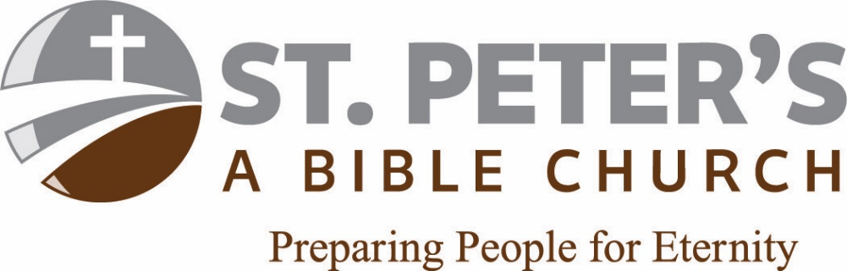
End Time Events October 29, 2023
Are We Living in the End Time? – Matthew 24:1-14
End time prophecy Matthew 24:1-3
1. When will these things happen?
2. What will be the sign of Your coming and
of the end of the age?
Signs of the End of Times Matthew 24:4-14
1. ____________________________ and false Christs will deceive the world
  - Deception has been a key tactic of Satan since Genesis 3
2. ____________________________ war
- The war(s) will be accompanied by natural disasters such as earthquakes and famines (starvation)
  - This does not mean the end of time is at hand, but rather just beginning: “the beginning of birth pangs”
3. ____________________________ of Israel
- There will be death of many of God’s people at this time as the Antichrist begins to build the intensity of destruction
  - Hatred will build toward God’s people, many being betrayed by family and friends
4. _________________________________ will accompany false prophecy
5. ____________________________ will overtake the world
6. True believers will ____________________________
7. The gospel will be preached _________________________
End Time Events October 29, 2023
Are We Living in the End Time? – Matthew 24:1-14
End time prophecy Matthew 24:1-3
1. When will these things happen?
2. What will be the sign of Your coming and
of the end of the age?
Signs of the End of Times Matthew 24:4-14
1. ____________________________ and false Christs will deceive the world
  - Deception has been a key tactic of Satan since Genesis 3
2. ____________________________ war
- The war(s) will be accompanied by natural disasters such as earthquakes and famines (starvation)
  - This does not mean the end of time is at hand, but rather just beginning: “the beginning of birth pangs”
3. ____________________________ of Israel
- There will be death of many of God’s people at this time as the Antichrist begins to build the intensity of destruction
  - Hatred will build toward God’s people, many being betrayed by family and friends
4. _________________________________ will accompany false prophecy
5. ____________________________ will overtake the world
6. True believers will ____________________________
7. The gospel will be preached _________________________
How should I live?
- Be careful to discern false prophecy
  - There are many prophets of doom on the internet right now claiming this is the end of the end
- Do not abandon Jesus Christ now because of the calamities in our world
  - Instead, read His words carefully, meditating upon them and seeking the Lord’s direction about the implications for us
- Pray for the peace of God’s people
  - Psalm 122:6a
Pray for the peace of Jerusalem.
- Remain dedicated to sharing the Gospel of Jesus Christ
  - Stay on mission!

How should I live?
- Be careful to discern false prophecy
  - There are many prophets of doom on the internet right now claiming this is the end of the end
- Do not abandon Jesus Christ now because of the calamities in our world
  - Instead, read His words carefully, meditating upon them and seeking the Lord’s direction about the implications for us
- Pray for the peace of God’s people
  - Psalm 122:6a
Pray for the peace of Jerusalem.
- Remain dedicated to sharing the Gospel of Jesus Christ
  - Stay on mission!

